**Screenshots of the System**

**User Interface**

**Home Page**



**Figure1 Home Page**

**Feedback Part**

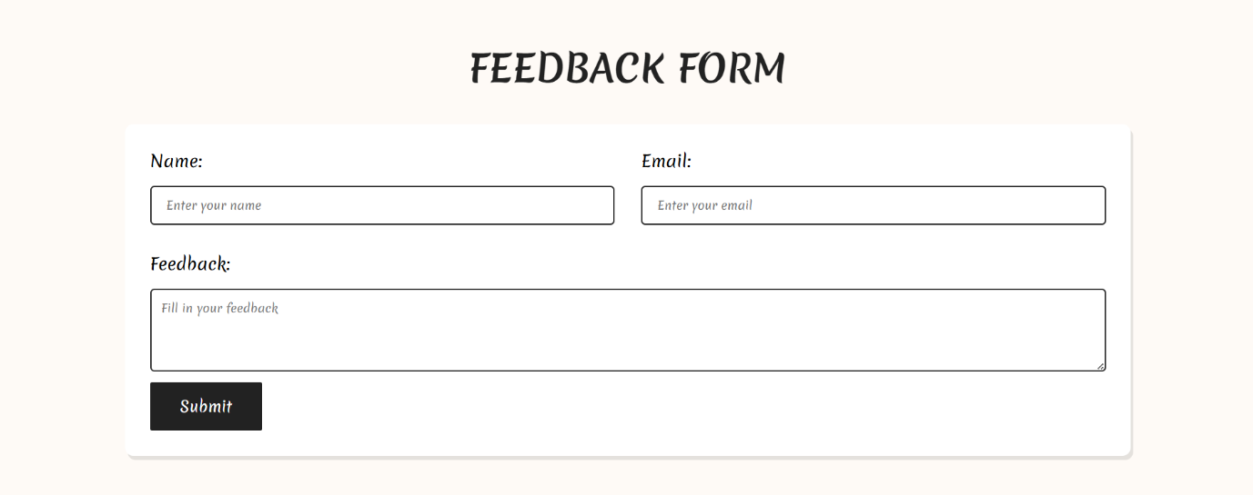

**Figure2 Feedback Part**

**Review Part**

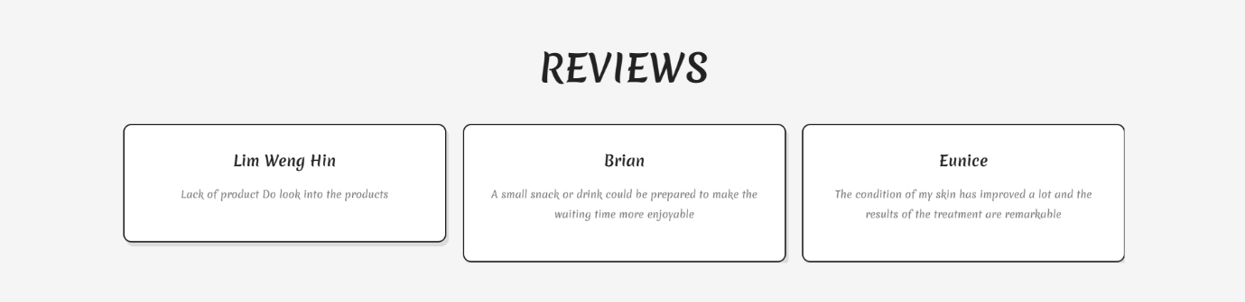

**Figure3 Review Part**

**Service Page**



**Figure4 Service Page**

**Appointment Page**

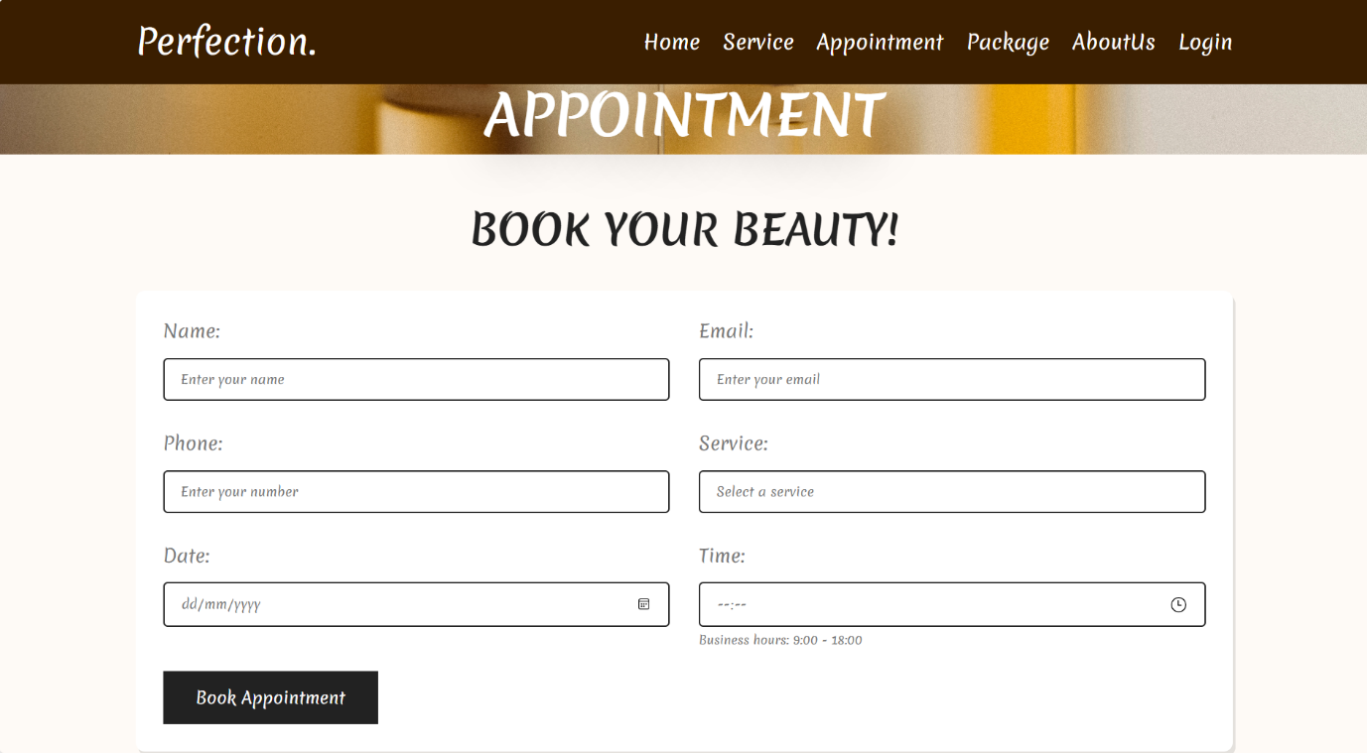

**Figure5 Appointment Page**

**Package Page**

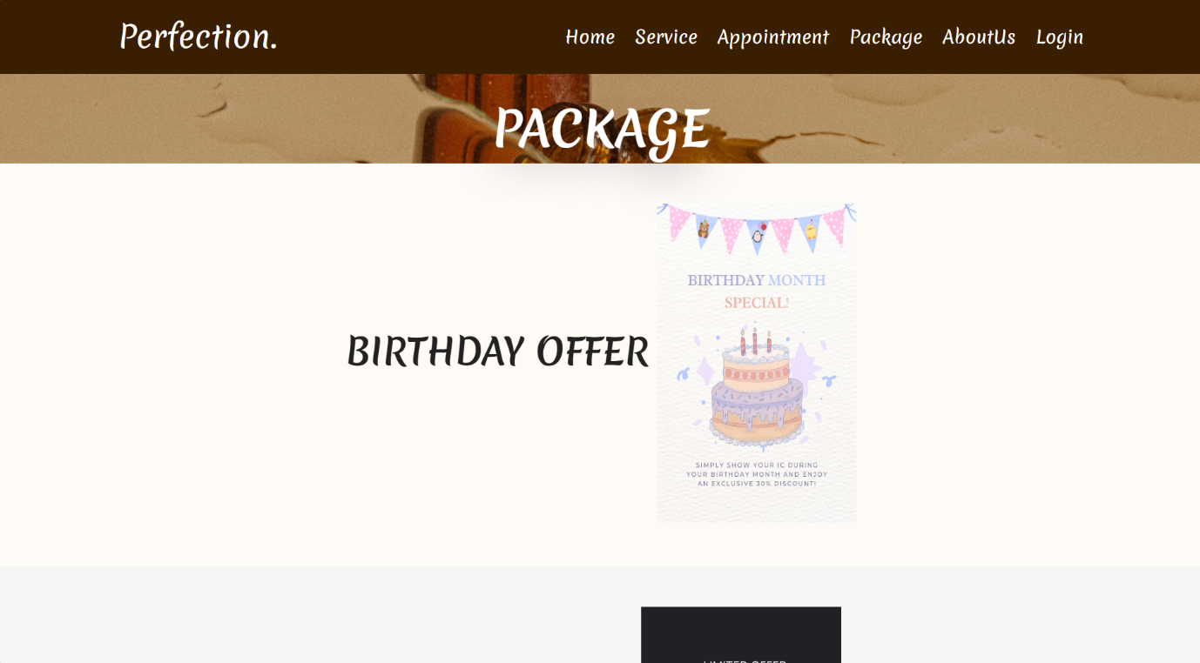

**Figure6 Package Page**

**About Us Page**



**Figure7 About Us Page**

**Footer Part**

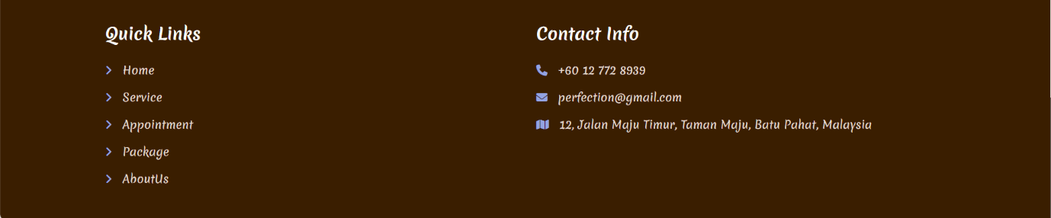

**Figure8 Footer Part**

**Login Page**

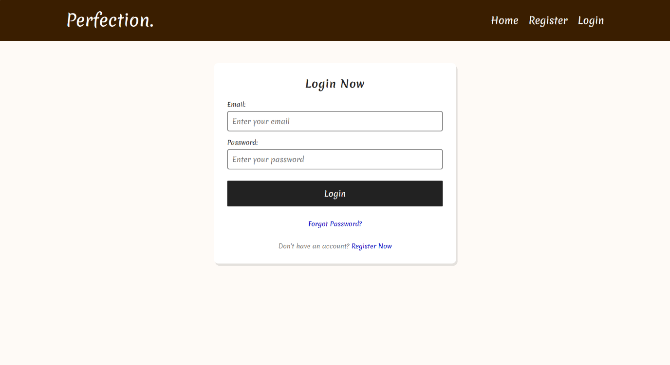

**Figure9 Login Page**

**Forgot Password Page**

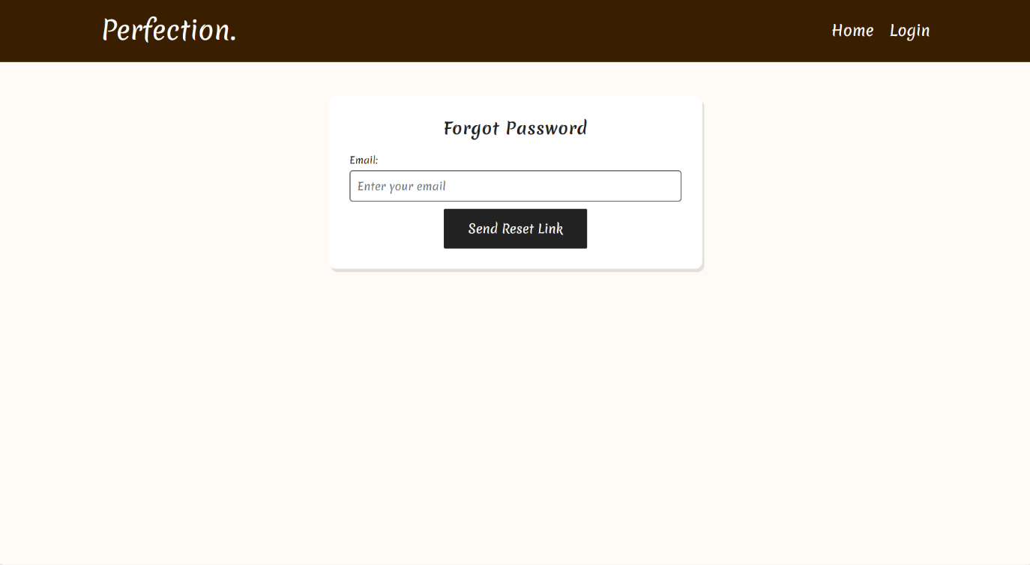

**Figure10 Forgot Password Page**

**Reset Password Page**

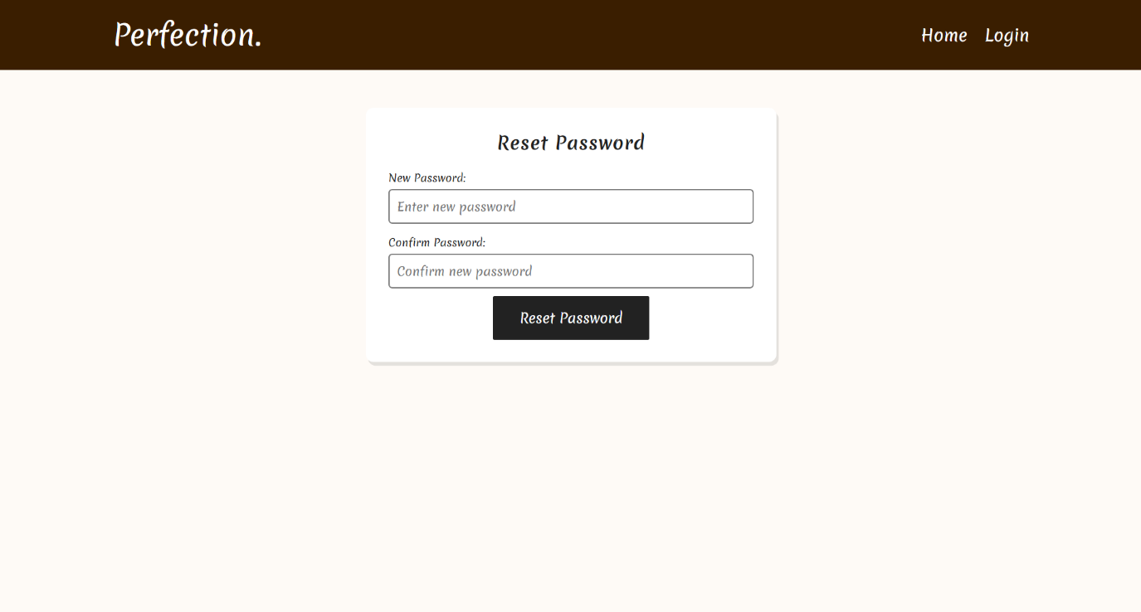

**Figure11 Reset Password Page**

**Register Page**

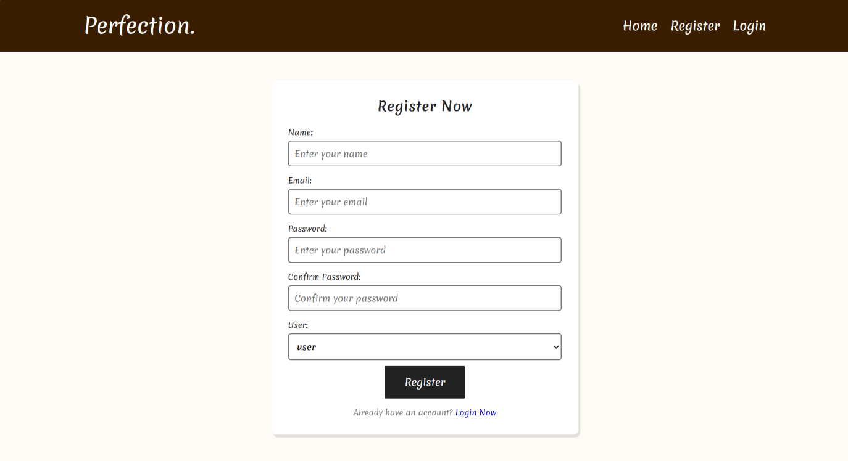

**Figure12 Register Page**

**Appointment Email**



**Figure13 Appointment Email**

**Feedback Email**

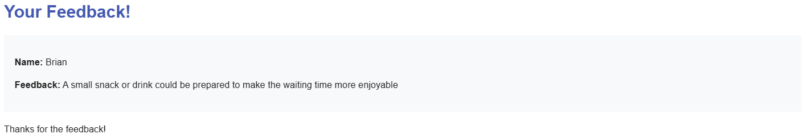

**Figure14 Feedback Email**

**Reset Password Email**

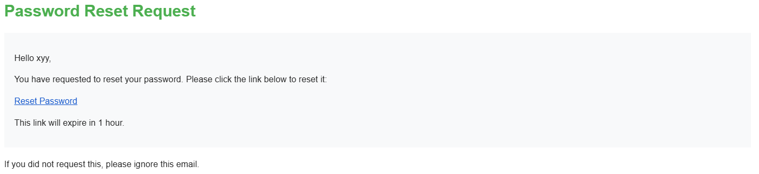

**Figure15 Reset Password Email**

**Admin Interface**

**Dashboard Page**

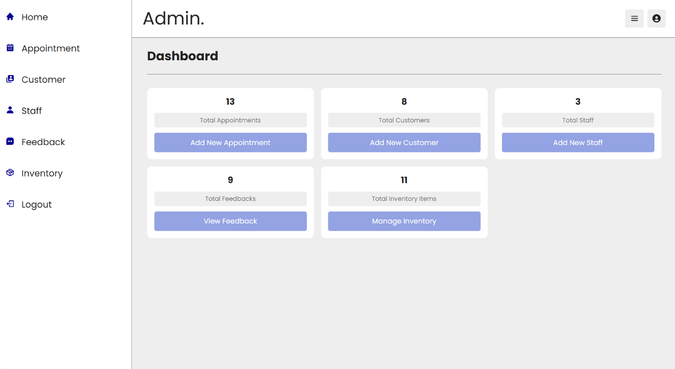

**Figure16 Dashboard Page**

**Manage Appointment Page**

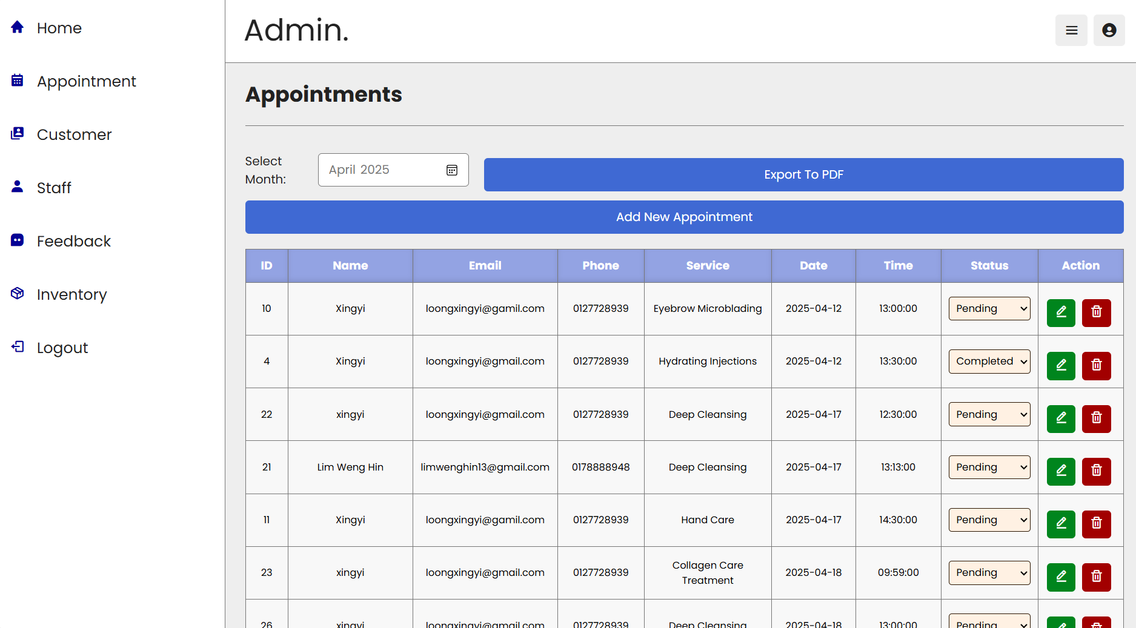

**Figure17 Manage Appointment Page**

**Add Appointment Page**

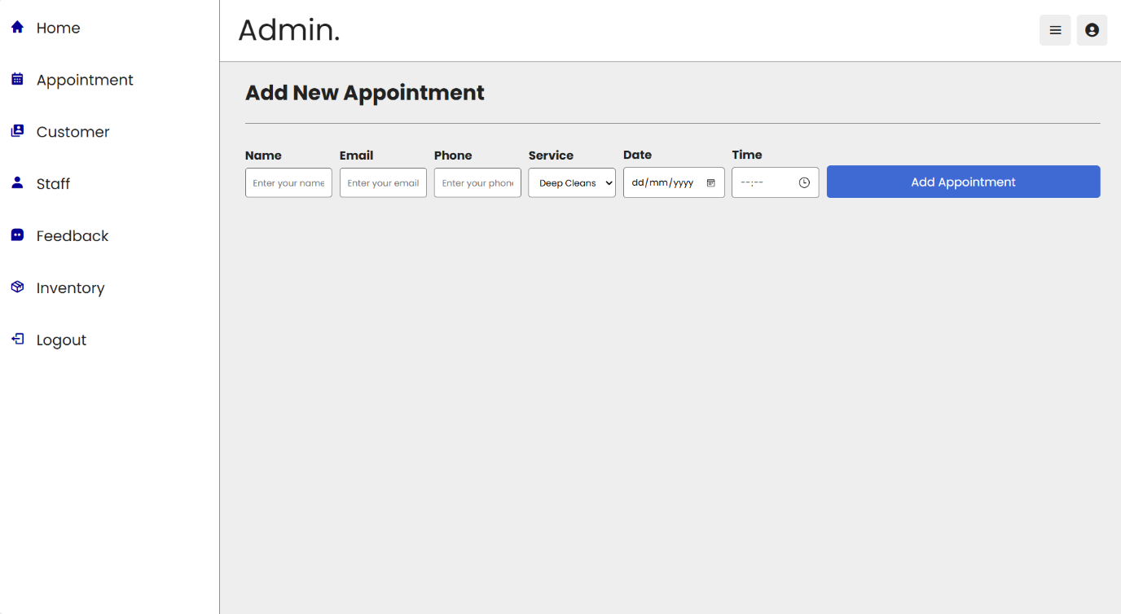

**Figure18 Add Appointment Page**

**Edit Appointment Page**

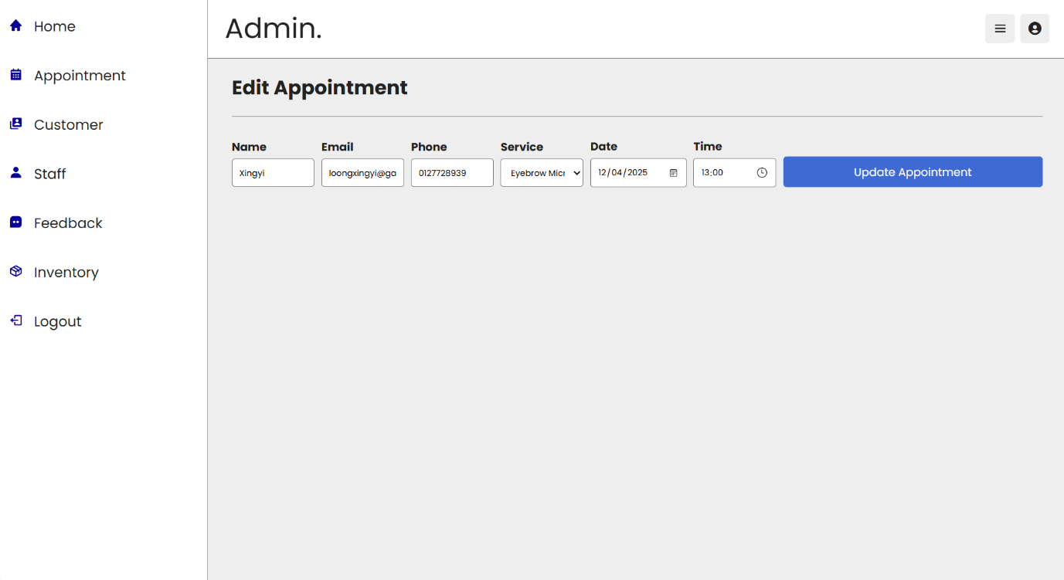

**Figure19 Edit Appointment Page**

**Report Appointment**

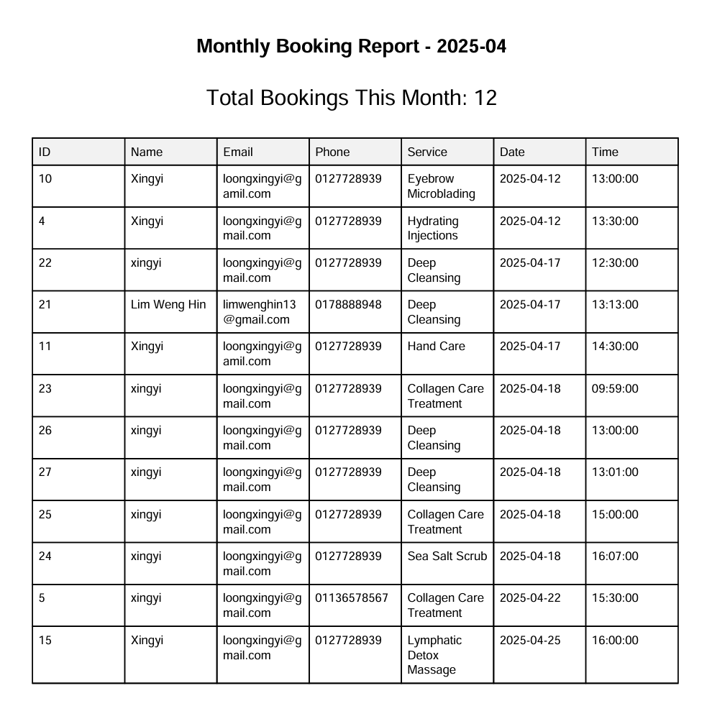

**Figure20 Report Appointment**

**Manage User Page**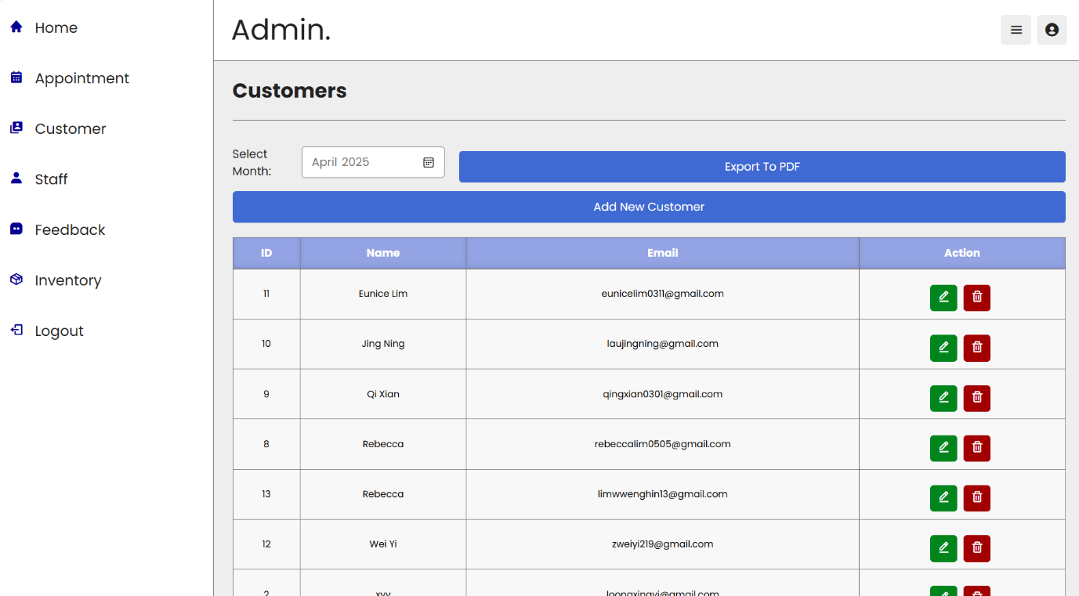

**Figure21 Manage User Page**

**Add User Page**



**Figure22 Add User Page**

**Edit User Page**



**Figure23 Edit User Page**

**Report User**

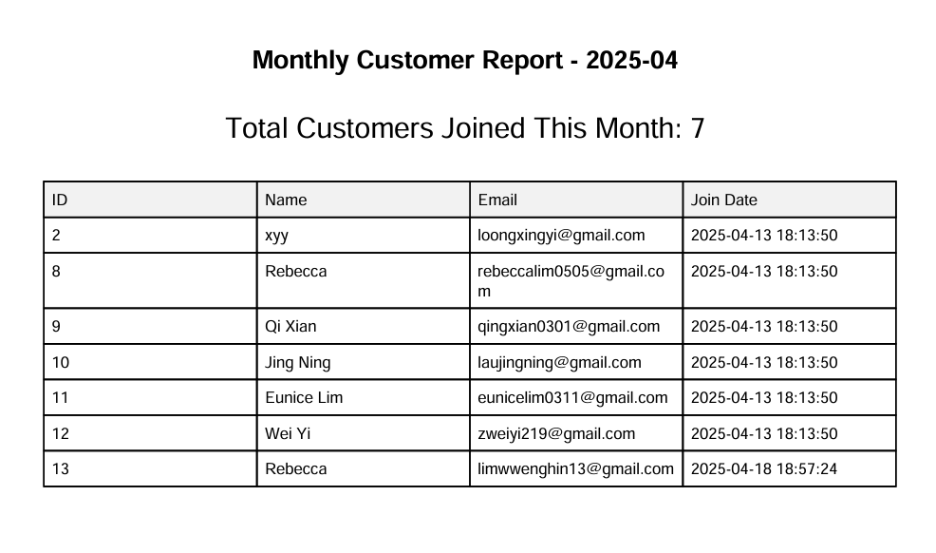

**Figure24 Report User**

**Manage Staff Page**

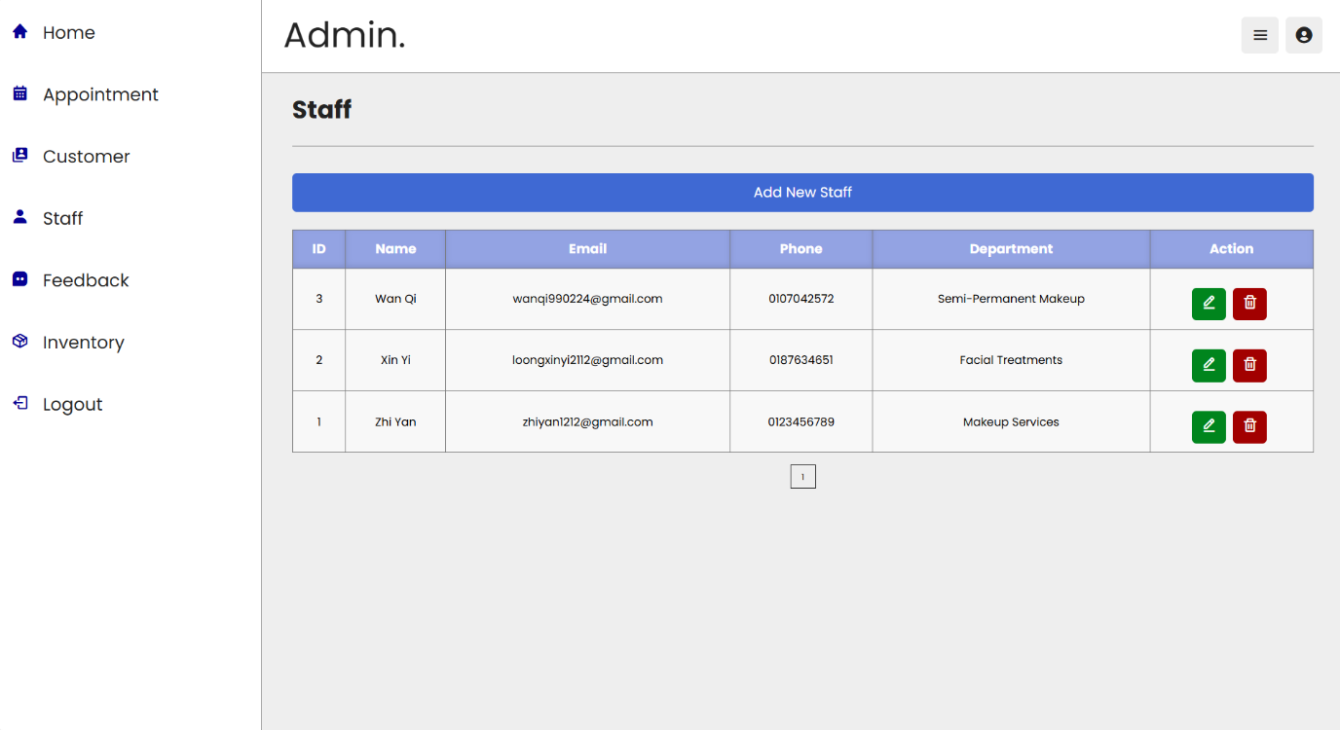

**Figure25 Manage Staff Page**

**Add Staff Page**

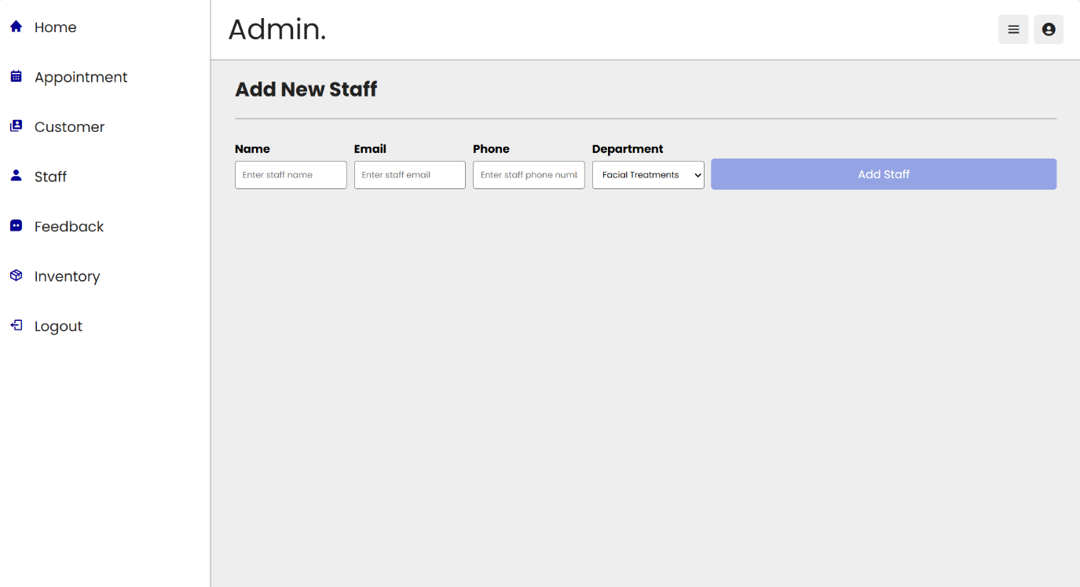

**Figure26 Add Staff Page**

**Edit Staff Page**

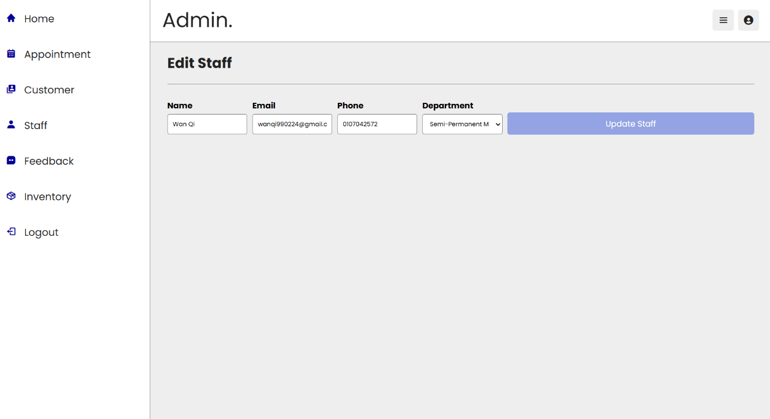

**Figure27 Edit Staff Page**

**Manage Feedback Page**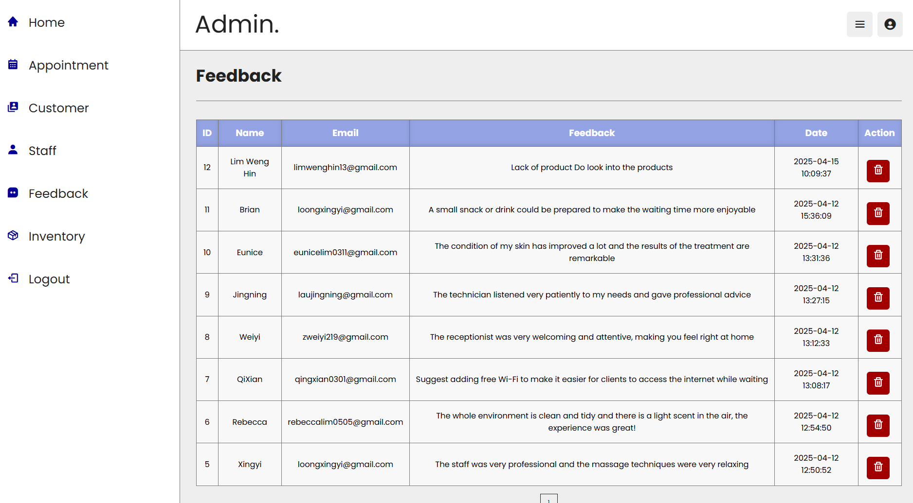

**Figure28 Manage Feedback**

**Manage Inventory Page**

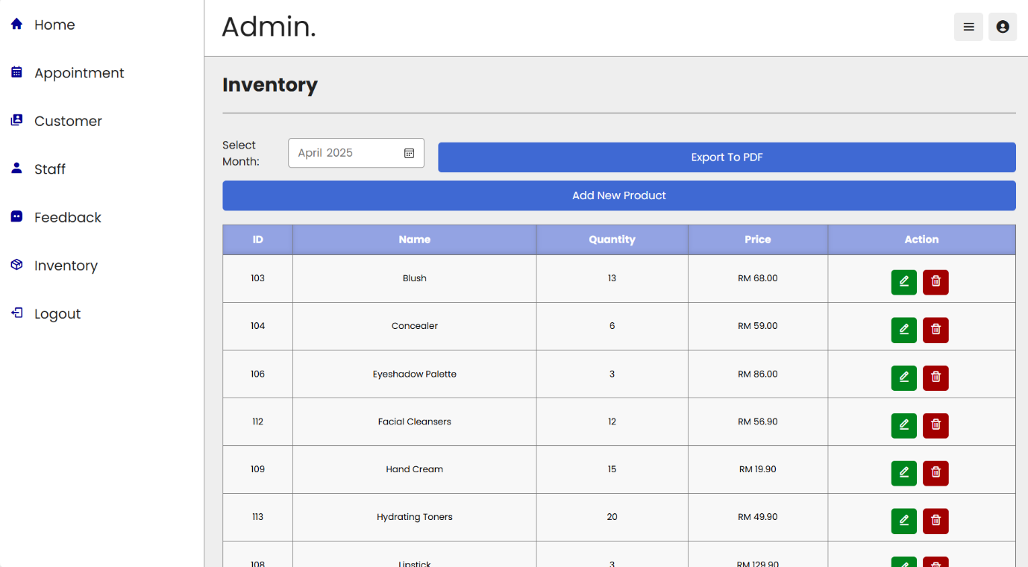

**Figure29 Manage Inventory Page**

**Add Inventory Page**

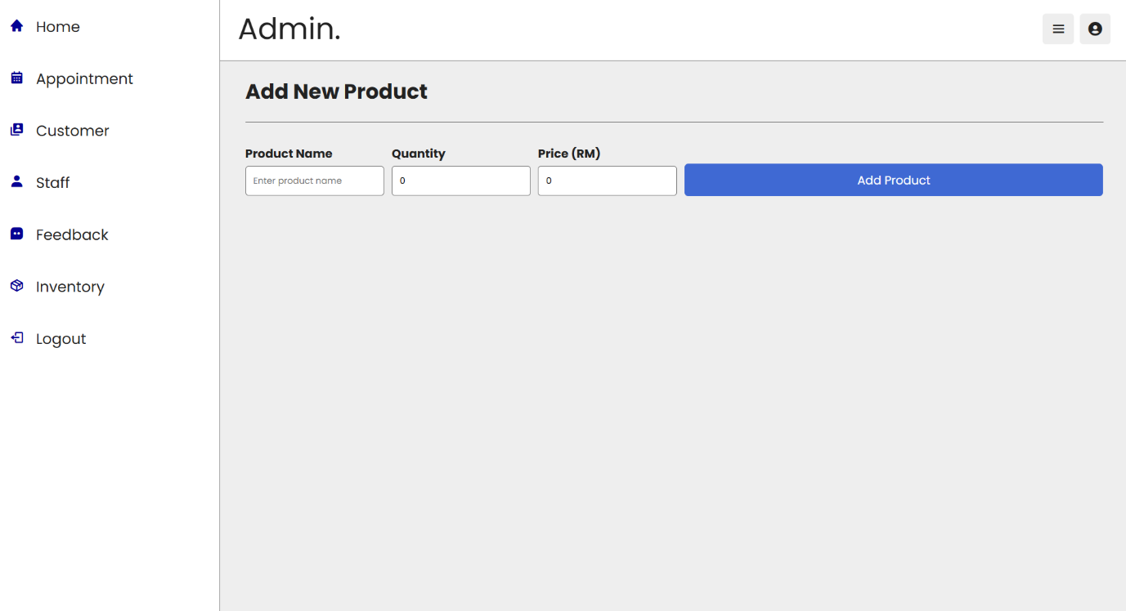

**Figure30 Add Inventory Page**

**Edit Inventory Page**

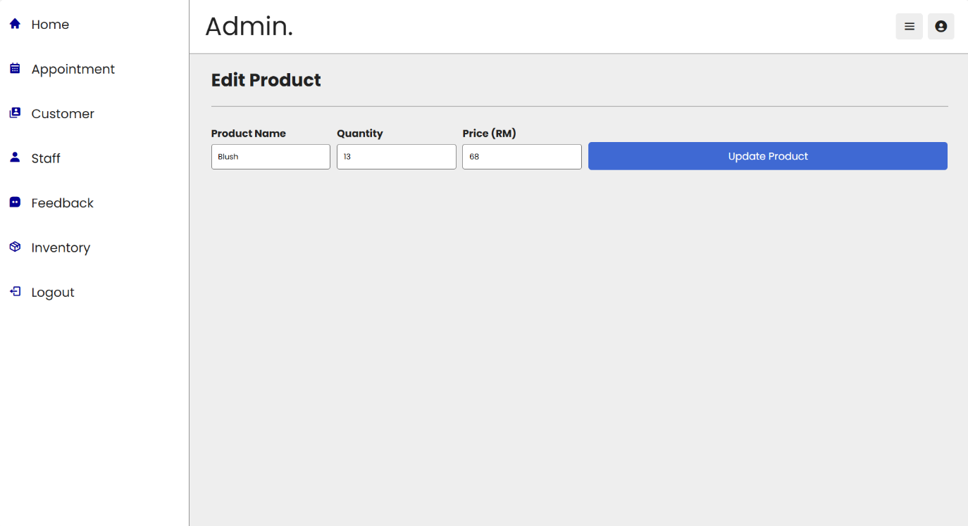

**Figure31 Edit Inventory Page**

**Report Inventory**

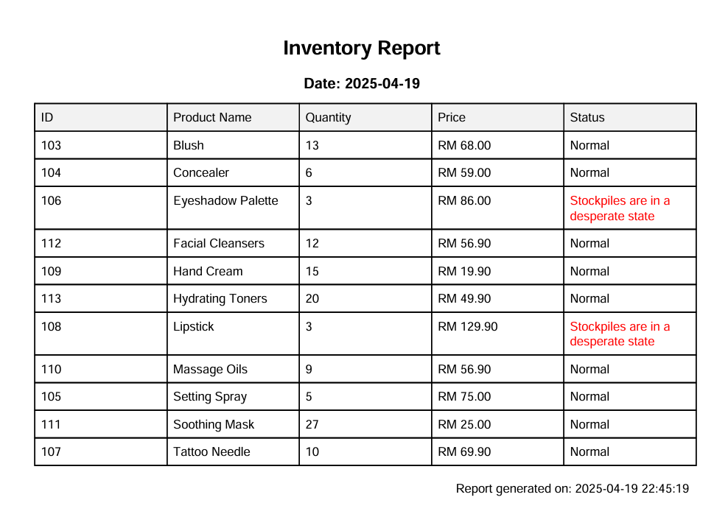

**Figure32 Report Inventory**